North Bay Summer Concert Series 2023 Artist Submission
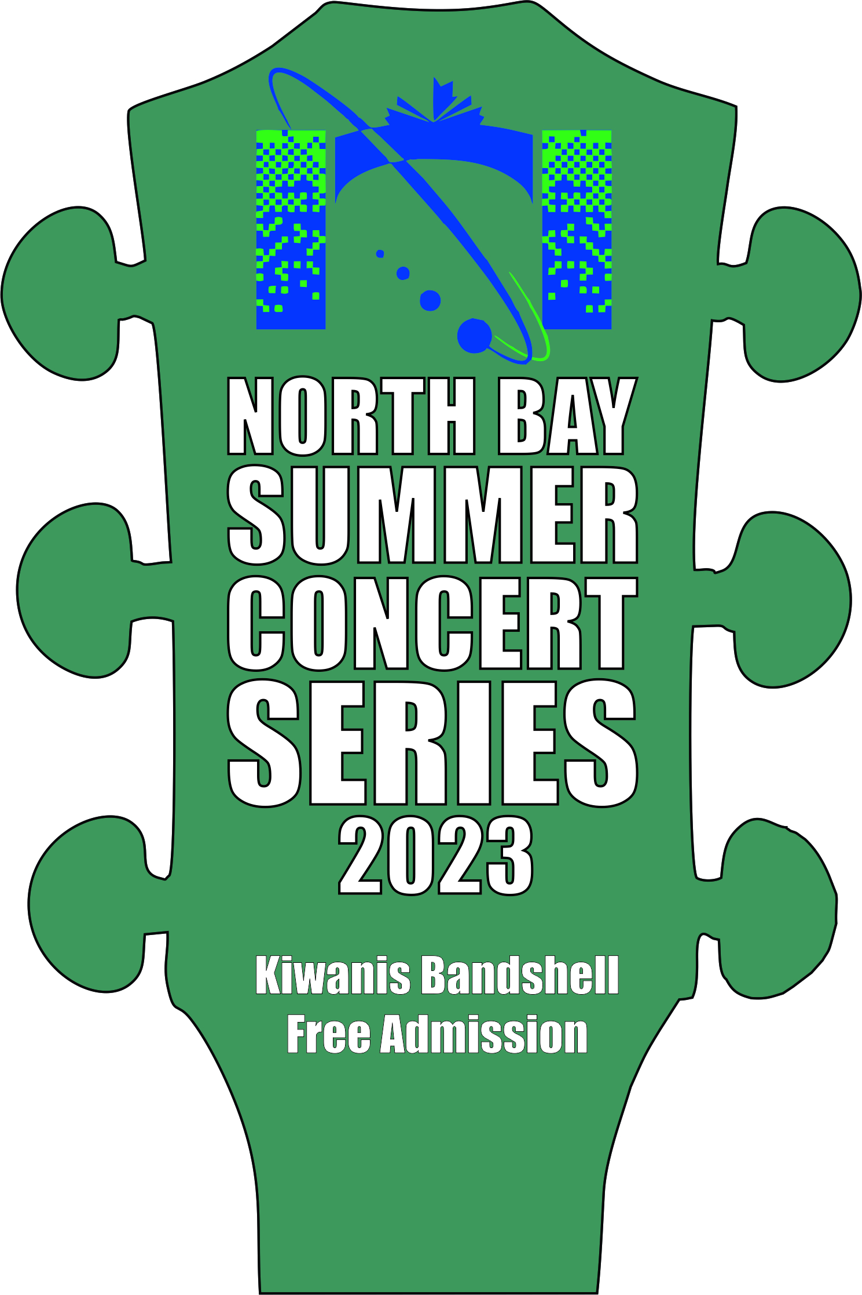
The City of North Bay and their partners are pleased to announce the North Bay Summer Concert Series 2023. This will be a series of free concerts held at the Kiwanis band shell on selected nights. The show dates are:

Saturday, July 1 (Canada Day)
Wednesday, July 5
Wednesday, July 12
Wednesday, July 19
Wednesday, July 26
Wednesday, August 2
Friday, August 4 (Hot Summer Night Festival)
Saturday, August 5 (Hot Summer Night Festival)
Wednesday, August 9
Wednesday, August 16
Wednesday, August 23
Wednesday, August 30

Artist Submission and FAQ's

If you would like to be considered for participation in the Concert Series, artist submissions are being accepted from now until March 24th, 2023 at 8am. Please click on the artist submission link below and complete the form. It is very important that you read the FAQ’s prior to your submission. A committee will review the submissions and prepare the line-up. The line-up will be announced shortly thereafter.

FAQ's

Do we get paid?

Wednesday Nights - Yes, you will be paid $120 per on-stage performer to a maximum of $600 per band plus $220 toward your PA system and crew. You will be paid in a timely manner following the show with a direct deposit from the city. You must complete a direct deposit form. This will be mailed to you after your selection to the concert series. Note - any payments above $500 will result in a T4 tax form being issued to the recipient. You may register each band member individually for direct deposit to avoid one person getting a lump sum payment.

Canada Day and Hot Summer Night Festival - $120 per on stage performer to a maximum of $600. A PA is provided in both of those cases so bands will not get the $220 PA allotment.

What gear is provided?

Wednesday Nights - There is no gear provided. You will have access to power at the back of the stage. All acts must be fully self-contained with a proper PA system with at least 2000 watts of power per side. All instruments must go through the PA system (amps, full drum kit, bass rig etc). We want a quality event. Please assume you may have 2000 people in attendance. If you do not have a PA system, Long and McQuade is one of our sponsors and will offer you a rental at a discounted rate. Money is allotted in your remuneration to help with PA and sound tech fees.

Canada Day and Hot Summer Night Festival - A PA is provided in both of those cases.

How loud do we play?

All shows - We should be good neighbours. Maximum sound pressure should not exceed 90dB. You can download an app to measure this.

Do we need lights?

Wednesday Nights - Shows in July do not need lights. Shows in August will need lights. You must supply your own lighting.

Canada Day and Hot Summer Night – Lighting will be provided.

Am I the only act on stage?

Wednesday Nights - Yes, the show is a one act performance without an intermission.

Canada Day and Hot Summer Night – this is a multi-act show. You will bring your own gear with the exception of PA and monitors. A backline is not provided.

What if it rains?

Wednesday Nights - The Wednesday is the official date. The following Thursday is a potential rain date. If you have arrived and set up, and the event is cancelled due to weather, you will be paid 100%. If the event is cancelled on the show date, prior to load-in, and there is no reschedule option, you will be paid 50%. If you can perform on an alternate date, prior to Labour Day, you will be paid the 100% for that date.

Canada Day & Hot Summer Night – As above with different rain dates.

What is the production schedule?

Wednesday Nights - You can load-in at 4:30pm and prepare for your show. The show should start around 7pm and run until about 9pm with no intermission. We need 90-120 minutes of entertainment.

Canada Day and Hot Summer Night – these events will have specific transition times prior to your performance. These shows are similar in length.

Will you consider acts from outside the area for the shows?

Wednesday Nights - Our goal is to use acts with the majority of their members living in the North Bay Nipissing area.

Canada Day and Hot Summer Night - Our goal is to use acts with the majority of their members living in the Nipissing area with the potential exception of some headline acts.

Is this for solo performers or groups?

Wednesday Nights - Our goal is to use groups.

Canada Day and Hot Summer Night – there might be one time slot per event for solo artists. This depends on submissions and budgets.

How many submissions do you anticipate?

All Shows - We expect to have 40-60 submissions.

What type of act is preferred?

All Shows - We prefer an established group with a strong following. This means they have a good social media presence and have lots of fans that routinely come to their shows. The more popular genres are rock, country, and blues.

How do you select the acts?

All Shows - There is no shortage of acts. We have an inventory of 30+ acts from the region from previous events. We have limited dates so a selection process must occur. The artist submission form indicates to us who is interested / available for these gigs. Our committee then looks for the best acts to entertain our demographic. Our main demographic is aged 35 plus. Then it’s a business decision for the final selection.

Do I get feedback on my artist submission?

All Shows - Only acts who have been selected will be contacted.

How can I improve my bands likelihood of being selected?

All Shows - Over time, develop a tight band with great vocal harmonies and pro level musicianship. Play lots of shows to develop your following. Create a strong social media presence. Come to the series yourself and support the other artists. Like and share our events to promote live music in the region.

How can I help?

All Shows - The easiest way to support the program is to attend the shows. Further, you can help by promoting the concerts (likes and shares are best) on social media.

Can I provide sponsorship?

All Shows – Yes, you are welcome to provide sponsorship to the program. Contact City Hall at 705-474-0400 ext 2321 or email bryan.kimber@northbay.ca for a sponsorship package.

Click here for the Artist Submission link.

https://docs.google.com/forms/d/1-xf6rC1SHJq5G06EIQ1SRjqG0mZVdm1LqUtBBVsMFS0/edit

